**QUIZ 1**

**Part 1: Answers**

1. A. These are the fields that are violating the 1NF rule.

* *Pet1, Pet2,*
* *Species 1, Species 2,*
* *DOB1, DOB 2,*
* *Appointment 1, Appointment 2,*
* *Chip1, Chip 2,*
* *Appointment Pet1, Appointment Pet 2,*
* *Appointment Procedure.*

B. I would start by first removing the repeating columns by creating columns:

* *Pet*
* *Species*
* *DOB*
* *Appointment*
* *Chip*
* *Appointment Pet*

Then I would split the data in the *‘Appointment Procedure’* field by creating a separate and unique record so that each field has scalar data entity.

1. My chosen composite primary keys are:

* *Veterinary Clinic Name*
* *Client First Name*
* *Client Last Name*
* *Chip*
* *Vet First Name*
* *Vet Last Name*

1. A. There are partial dependencies;

* On the *Veterinary Clinic Name* by*; Veterinary Clinic Address, Veterinary Clinic Phone Number, Veterinary Clinic Email*
* On the *Client FirstName* and *LastName* by; *Client Address, Client Phone Number, Client Email.*
* On the *Chip* by*; Pet, Species, DOB*
* On *Vet FirstName* and *LastName* by; *Vet Phone Number, Vet Extension Number, Vet Office.*

B. I would create three tables:

Veterinary Clinic Table, Pet Info Table, and Veterinarian Info Table.

1. I can find transitive dependency with the appointment details fields;

*Appointment, Appointment Pet, Appointment Procedure, Appointment Location*.

A quick fix for this I suggest would be to add an ‘Appointment ID’ field used as a primary key in an ‘Appointment info table’ and have all these other fields put there.

**Part 2: Answers**

**1.**

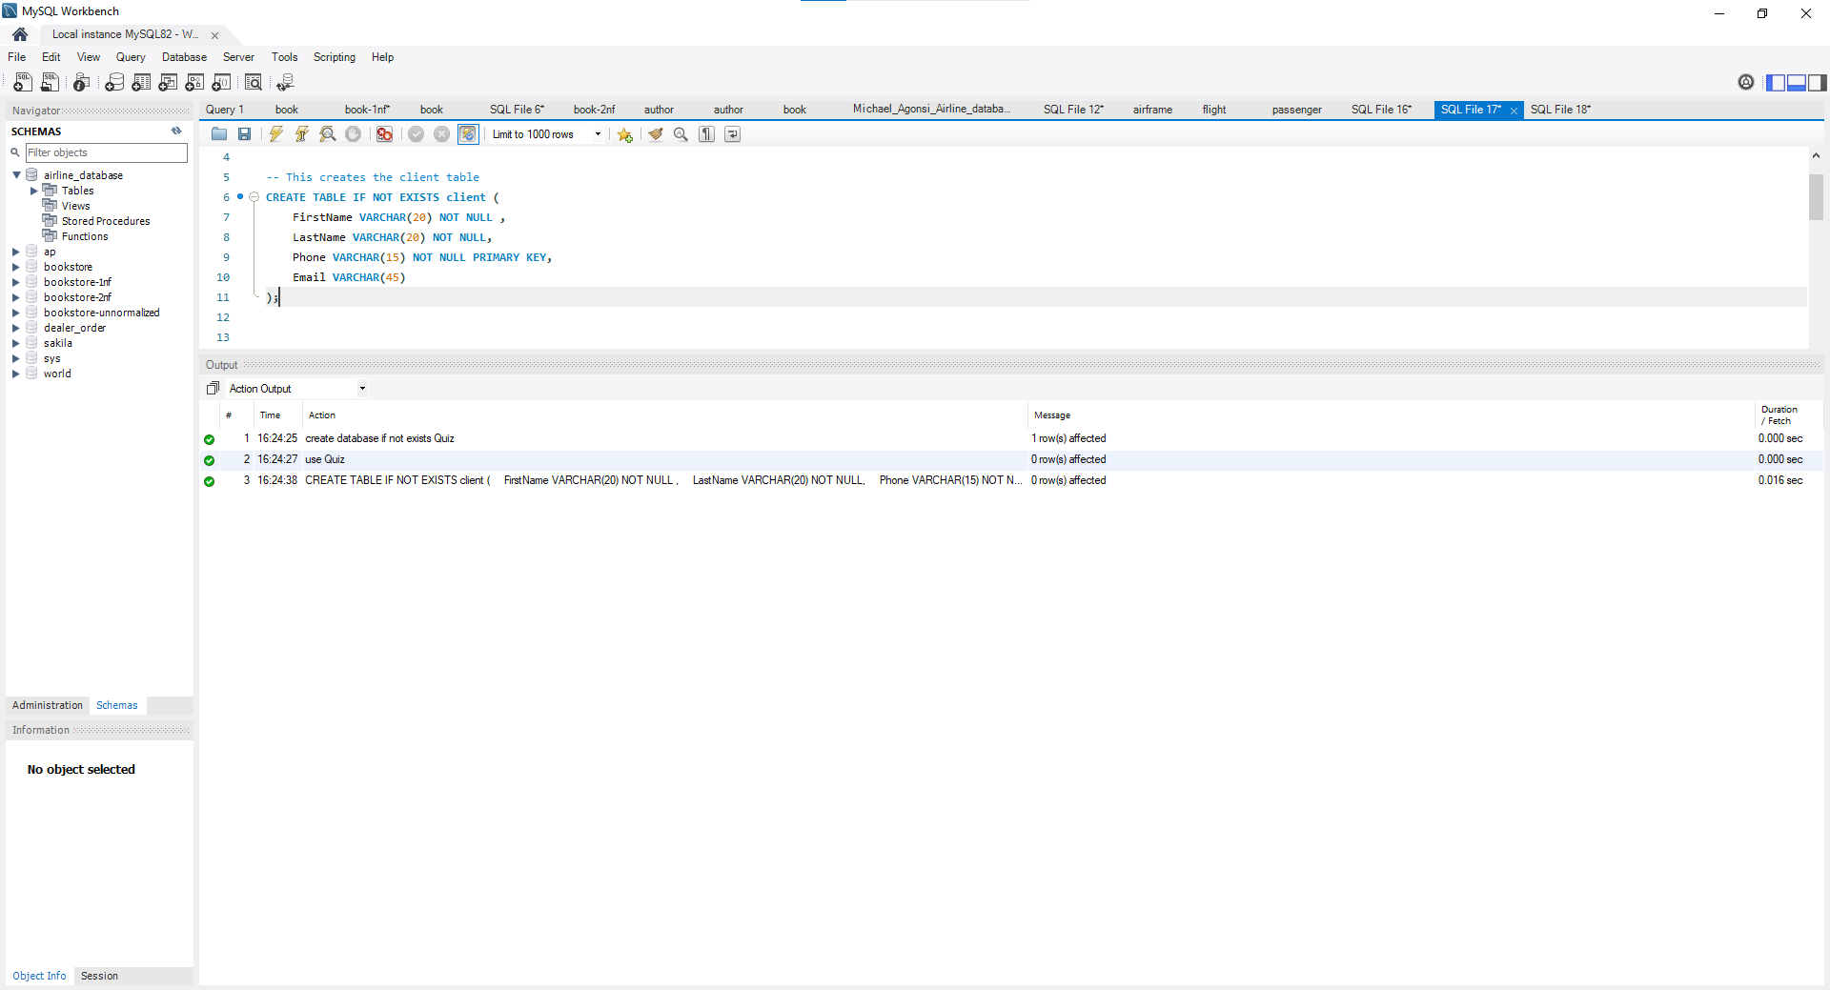

**2.**

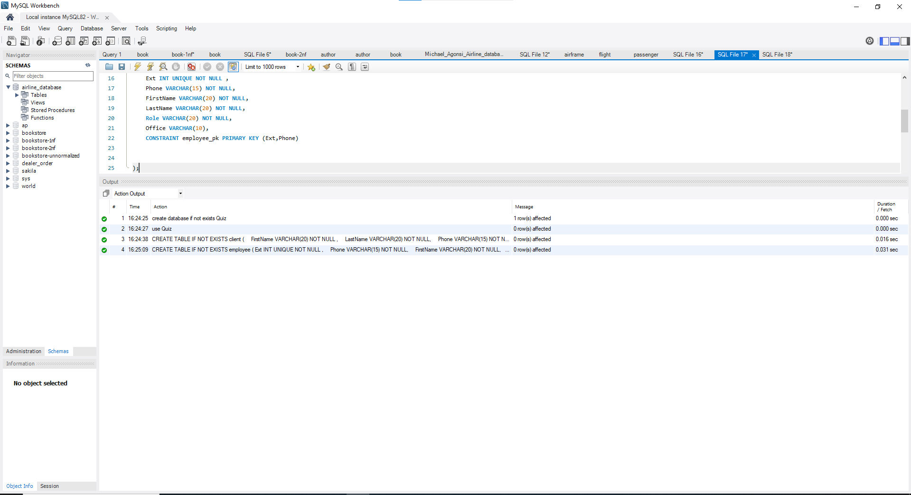

**3.**

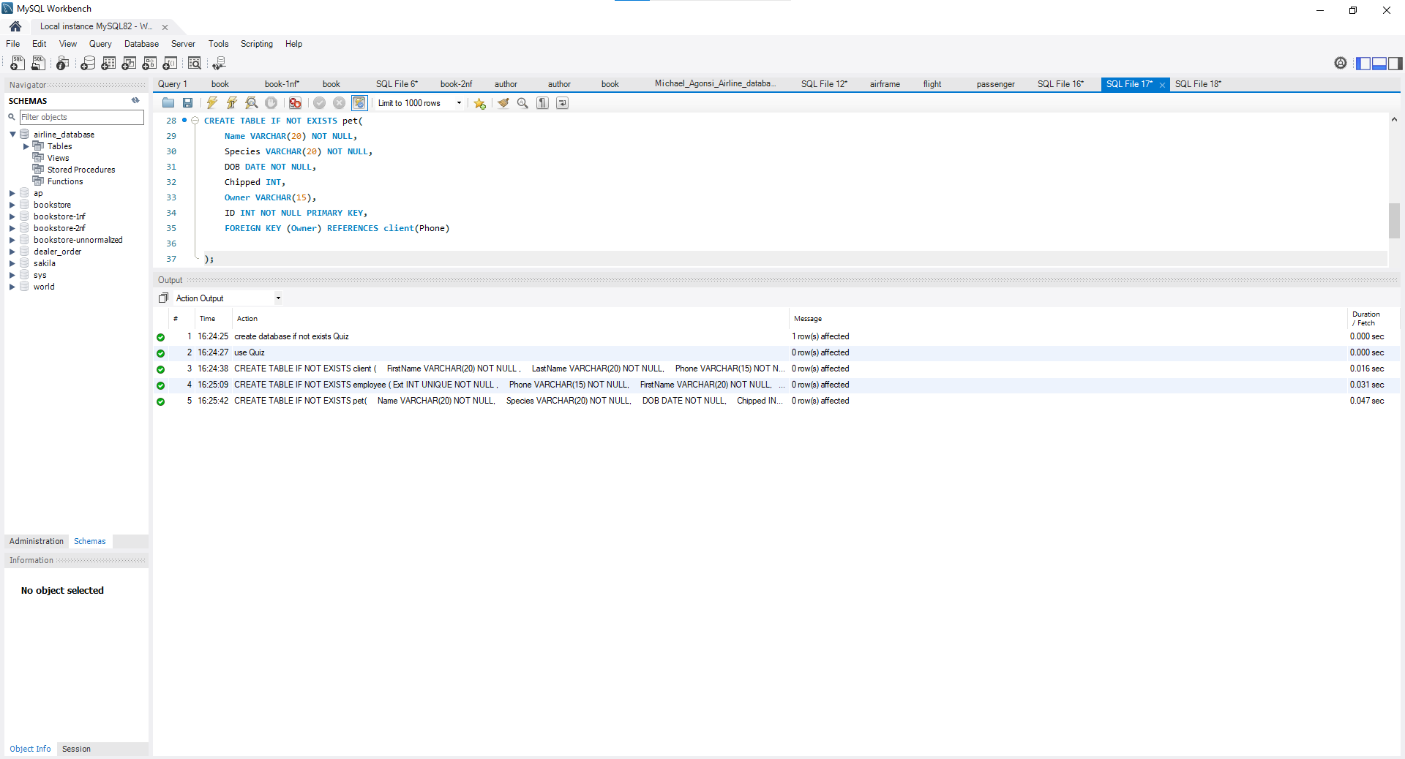

**4**

